CIS 324: Language Design and Implementation

Operator Precedence Parsing

1. Precedence Relations

Bottom-up parsers for a large class of context-free grammars
can be easily developed using operator grammars.

Operator grammars have the property that no production right side
is empty or has two adjacent nonterminals. This property enables the
implementation of efficient operator-precedence parsers. These
parser rely on the following three precedence relations:

Relation | Meaning
a <· b | a yields precedence to b
a =· b | a has the same precedence as b
a ·> b | a takes precedence over b
These operator precedence relations allow to delimit the handles
in the right sentential forms: <· marks the left end, =· appears in
the interior of the handle, and ·> marks the right end.

Let assume that between the symbols a_{i} and a_{i+1} there is exactly
one precedence relation. Suppose that $ is the end of the string.
Then for all terminals we can write: $ <· b and b ·> $. If we
remove all nonterminals and place the correct precedence relation:
<·, =·, ·> between the remaining terminals, there remain strings
that can be analyzed by easily developed parser.

For example, the following operator precedence relations can
be introduced for simple expressions:
 | id | + | * | $
id |  | ·> | ·> | ·>
+ | <· | ·> | <· | ·>
* | <· | ·> | ·> | ·>
$ | <· | <· | <· | ·>

Example: The input string:
id₁ + id₂ * id₃

after inserting precedence relations becomes
$ <· id₁ ·> + <· id₂ ·> * <· id₃ ·> $

Having precedence relations allows to identify handles as follows:

- scan the string from left until seeing ·>

- scan backwards the string from right to left until seeing <·

- everything between the two relations <· and ·> forms the handle

Note that not the entire sentential form is scanned to find the handle.
2. Operator Precedence Parsing Algorithm

Initialize: Set ip to point to the first symbol of w$
Repeat: Let X be the top stack symbol, and a the symbol pointed to by ip
if $ is on the top of the stack and ip points to $ then return
else
Let a be the top terminal on the stack, and b the symbol pointed to by ip
if a <· b or a =· b then
push b onto the stack
advance ip to the next input symbol
else if a ·> b then
repeat
pop the stack
until the top stack terminal is related by <·
to the terminal most recently popped
else error()
end

3. Making Operator Precedence Relations

The operator precedence parsers usually do not store the precedence
table with the relations, rather they are implemented in a special way.

Operator precedence parsers use precedence functions that map
terminal symbols to integers, and so the precedence relations
between the symbols are implemented by numerical comparison.

Not every table of precedence relations has precedence functions
but in practice for most grammars such functions can be designed.

Algorithm for Constructing Precedence Functions

1. Create functions f_{a} for each grammar terminal a and for the
end of string symbol;

2. Partition the symbols in groups so that f_{a} and g_{b} are in the
same group if a =· b ( there can be symbols in the same group
even if they are not connected by this relation);

3. Create a directed graph whose nodes are in the groups, next for each
symbols a and b do: place an edge from the group of g_{b} to the group
of f_{a} if a <· b, otherwise if a ·> b place an edge from the group of
f_{a} to that of g_{b};

4. If the constructed graph has a cycle then no precedence functions
exist. When there are no cycles collect the length of the longest
paths from the groups of f_{a} and g_{b} respectively.
Example: Consider the above table
 | id | + | * | $
id |  | ·> | ·> | ·>
+ | <· | ·> | <· | ·>
* | <· | ·> | ·> | ·>
$ | <· | <· | <· | ·>

Using the algorithm leads to the following graph:
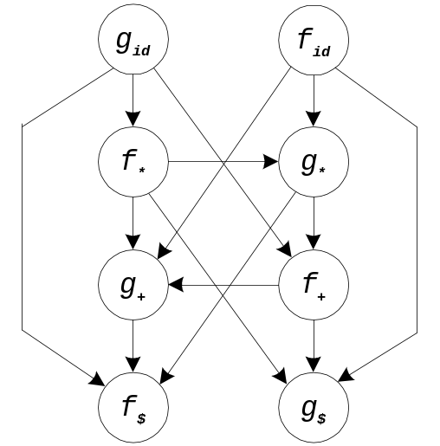

from which we extract the following precedence functions:
 | id | + | * | $
f | 4 | 2 | 4 | 0
g | 5 | 1 | 3 | 0

